**Republic Democratic Popular Of Algeria**

**Ministry Of Transport**

**E T F I M Mostaganem**

**Long Term Training**

**Section : Engine Room Seafarers**

**Module: English**

**Teacher: Mrs Douar Rym**

**Maritime English Grammar**

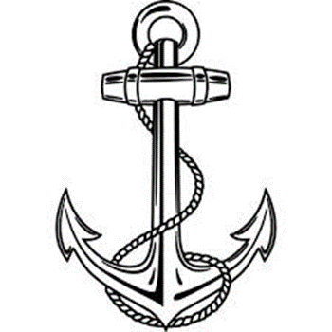

**Lesson One: The Simple Present**

**1/Introduction To Grammar**

Grammar includes the rules that govern the way sentences are formed and words are used to make meaning.

**2/Present Simple Tense :**

We use the simple present for things in general or things that happen repeatedly.

**A/Simple Present (be: am / is/ are)**

|  |  |  |
| --- | --- | --- |
| **Positive Form** | **Negative Form** | **Interrogative Form** |
| I am/ I’m | Iam not/ I’m not | Am I? |
| He is / he’s | He is not/ he’s not  He isn’t | Is he? |
| She is/ she’s | She is not / she’s not  She isn’t | Is she ? |
| It is / it’s | It is not/ it’s not  It isn’t | Is it? |
| We are/ we’re | We are not/ we’re not  We aren’t | Are we? |
| You are/You’re | You are not/ you’re not  You aren’t | Are you ? |
| They are / they’re | They are not/ they’re not / they aren’t | Are they ? |

***\*Short Forms:***

**Examples:**

**A-Positive Form**

1/I’m a seaman.

2/The Bosun ‘s 35 years old.

3/The Third officer and The Third Engineer are good friends.

4/We’re in the Engine Room.

**B-Negative Form:**

1/She isn’t a Stewardess. She’s a Passenger.

2/These Seamen aren’t Spanish .They ‘re Creek.

3/You aren’t a sailor .You ‘re a captain.

**C-Interrogative Form:**

1/Are these tugs new? Yes; they’re

2/Is this a passenger liner? No ; she is a cruiser or it’s cruiser.

**D/Questions and Short Answers:**

1/Are you The Chief Engineer ? yes, I’m.

2/Is The Electrical Officer sick? No, he isn’t

3/Are these passengers British ? Yes , they ‘re

**Practise: Exercises**

**A/ Write the Short Form:**

1-he is : …he’s……………………….

2-we are: ……………………….

3-it is not: ……………………….

4-you are not: …………………..

5-i am not: ……………………….

**B/Put in: am ,is ,are, isn’t, aren’t, .**

1-What ship is she.

2-They ………………..officers. They ………………(not) steward.

3-………………….you the Master? Yes, i…………………. .

4-The Captain and The Second Engineer …………………….. in the Engine room.

5-…………………he The Electrician? No , he ……………………………. .

**C-Put in The Interrogative and The Negative:**

|  |  |  |
| --- | --- | --- |
| **Positive sentences** | **Interrogative** | **Negative** |
| 1-Iam a captain | …am I a captain? | I ‘m not a captain |
| 2-You are a passenger | ……………………………………..? | …………………………………….. |
| 3-It is a cargo ship | ………………………………………? | ……………………………………… |
| 4-We are sailors | ………………………………………? | …………………………………….. |
| 5-They are tankers | ……………………………………….? | ……………………………………. |

**The Objective Of The Lesson :**

**\*Pupils can correctly use the simple present.**

**\*Pupils will be familiar with Maritime English Words Like:**

**Passengers/ ship/tugs/captain /electrical officer/master/stewards/engine room /cruiser/tankers/seamen/sailors/cargo/the second engineer/steward/bosun.**

NB: The lesson has references.